Load Factor Analysis
Norbert Doerry
May 23, 2026
- Introduction
Load factor analysis is a traditional bottoms-up estimate of the electrical load for different operating conditions and different ambient conditions. The load list incorporates every load on the ship along with its connected load. In load factor analysis, a load factor is assigned to each load for each combination of ambient condition and operating condition; the operating load for a given load is the load factor multiplied by its connected load. The total operating load is the sum of the individual operating loads of each load. The ship demand power and 24 hour average loads are obtained by applying margin and service life allowance to the total operating load.
In shipboard analysis, load factor analysis is typically applied to determining the required rating of the generator sets. In this application load factor analysis is applicable if there are many loads and no load that varies appreciably in time is a significant fraction of the total load. Load factor analysis is also appropriate for calculating 24 hour average electric load. Load factor analysis may result in under-estimating the ship demand power if there are a significant number of cycling loads, or if one or more varying loads are a significant fraction of the total load. In these cases, an alternative load estimating method such as zonal load factors should be employed.
- Cycling loads
Figure 1 depicts a waveform of a cycling load. Cycling loads are typically on for a period of time, then off for possibly a different period of time. The time that the load is off and the load is on can vary. In this case, the load has a peak value of 10 kW; is on between 3 and 5 time units, and is off between 9 and 15 time units. The on and off times are randomly selected within their limits.
Assuming the peak value is the connected load, the appropriate load factor for 24 hour average computations would be calculated by dividing the waveforms average value by its connected load. In Figure 1, the average value of the waveform is 2.6 while the connected load (assuming the peak load and connected load are the same) is 10. The load factor is therefore 0.26.
Determining an appropriate load factor for a cycling load when determining the required rating of power system equipment is more challenging. In Figure 1, using the load factor based on the long-term average may not be appropriate; supplying the peak load may result in overloading the power system equipment. On the other hand, if the cycling load is one of many loads, using a load factor of 1.0 to ensure being able to power the peak load is likely much too conservative. If the cycling load is one of only a few loads supplied by the power system equipment, then another modeling method, such as zonal load factors, should be employed.
Figure 2: depicts the combined power waveform of 50 cycling loads that have the same stochastic properties as the load in Figure 1. With a connected load of 500 kW, the total load seldom exceeds 200 kW; indicating a load factor of 0.40 would likely be adequate for equipment sizing. Since most power system equipment is not typically loaded beyond 95% of the equipment rating, the few times the load momentarily exceeds 200 kW should be accommodated by the power system equipment. If the total load included a significant amount of constant power loads, of if the power equipment has a significant overload capability, the load factor could be lowered to a value closer to the average value; the increased equipment rating also increases the magnitude of power fluctuations that can be tolerated.
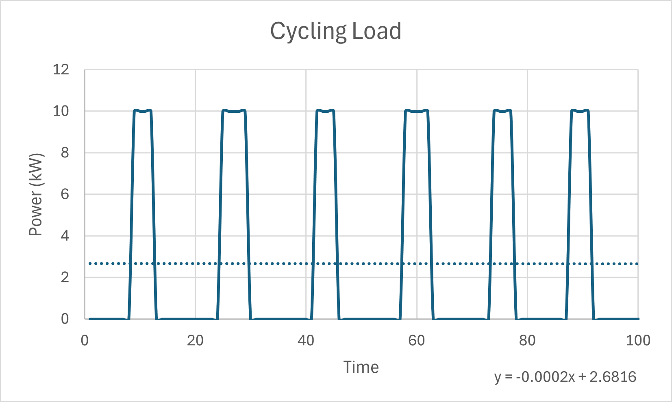
Figure 1: Cycling Load
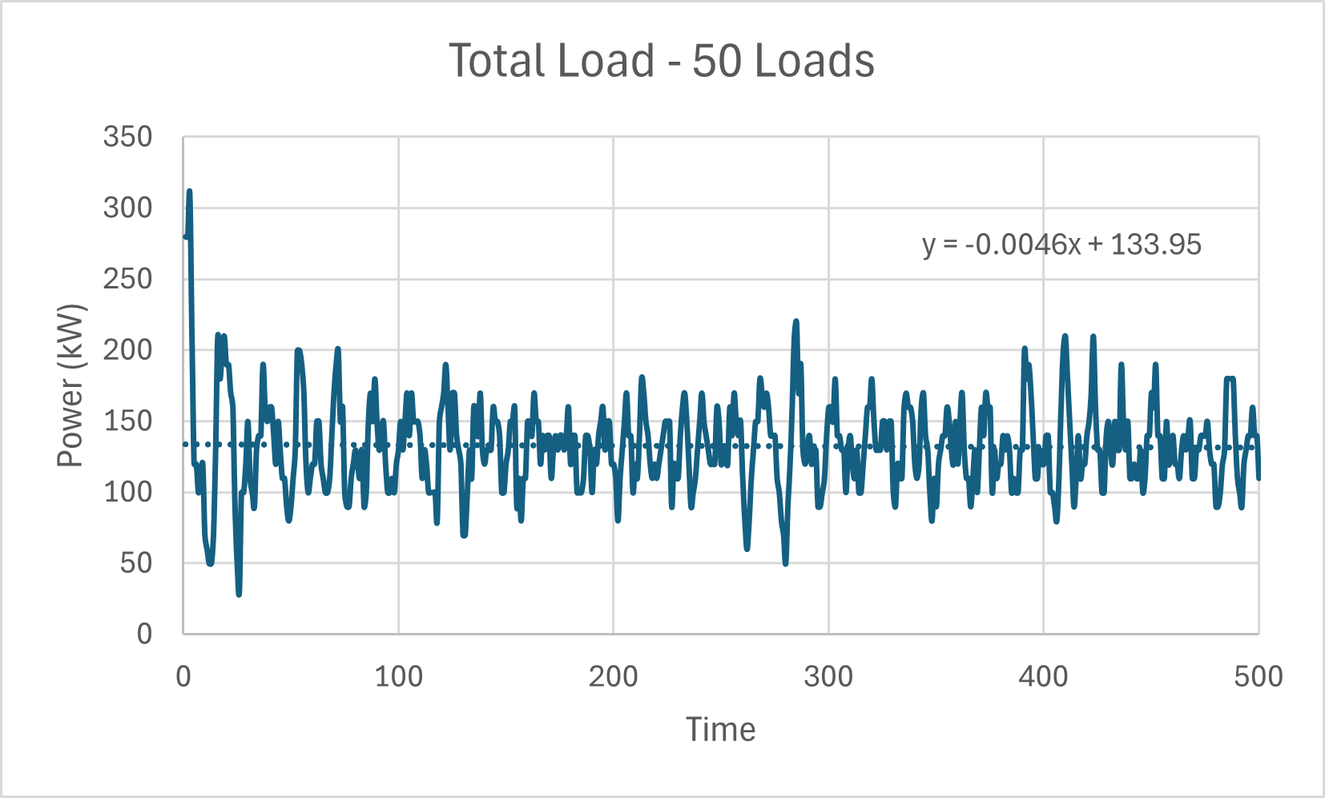
Figure 2: Power waveform for 50 cycling loads
The appropriate load factor for a cycling load depends on collective behavior of all the online loads as well as the power distribution system equipment. Choosing a load factor for a cycling load should consider the impact of the load on the variability of the total load as well as the expected loading and overload capability of the power system equipment.
- Determining Load Factors
  - Load analysis
During ship design, load analysis is the preferred process for determining a load factor. The following guidance is provided in DPC 310-1:
“a. In assigning load factors, the following shall be considered: Zero load factors are assigned to seldom used equipment.
b. For ship demand power calculations, a load factor of 0.9 is typically used in cases where a motor operates at full load for an extended period of time during a specific ship condition. For 24-hour average load calculations, the load factor should reflect the long-term average load.
c. All standby units shall be listed and assigned zero load factors except when the standby unit is actually kept running or is based on percent of power used while idling.
d. Some ships are required to provide power to other ships, vehicles, and non-organic systems. Load analysis shall take into consideration the supply of power to these users of shipboard power.
e. If a load factor for 24-hour average calculations is known, the load factor for ship demand power can be approximated by applying the curve shown in figure 3 and (the following equation; use the zonal load factor for load j as the load factor for ship demand power; the equations are applicable for cycling and intermittent loads):
$$L_{fz_{j}}=L_{f_{j}}+\left(\frac{P_{P_{j}}}{P_{L_{j}}}-L_{f_{j}}\right)\left(\frac{P_{P_{j}}}{\sum_{i=1}^{n}{L_{f_{i}}P_{L_{i}}}}\right) \text{for} \frac{P_{P_{j}}}{\sum_{i=1}^{n}{L_{f_{i}}P_{L_{i}}}}<1.0$$
$$L_{fz_{j}}=\frac{P_{P_{j}}}{P_{L_{j}}} \text{for} \frac{P_{P_{j}}}{\sum_{i=1}^{n}{L_{f_{i}}P_{L_{i}}}}≥1.0$$
Where
$L_{fz_{j}}$ = Zonal load factor for load j
$L_{f_{j}}$ = Load factor for load j for 24-hour average calculations
$P_{L_{j}}$ = Connected Load (kW) for load j
$P_{P_{j}}$ = Peak Load (kW) for load j
$n$ = Number of loads
f. For mutually exclusive loads, the load with the higher operating load value shall be assigned the appropriate load factor and the load with the lower operating load value shall be assigned a load factor of 0. (For ship demand power calculations; for 24-hour average calculations, the load factor should equal the average power divided by the connected load for each of the loads)”
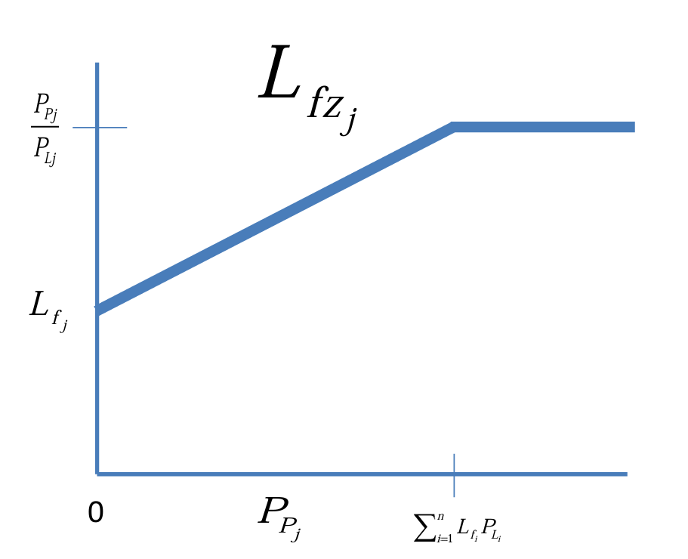
Figure 3: Zonal load factor
DPC 310-1 also provides guidance with respect to choosing load factors for motors:
“In selecting the size of a motor necessary to drive an auxiliary at its rated output, a larger motor than actually required is normally chosen because:
(1) In the design of the driven auxiliary, some margin in excess of calculated kW is allowed. Accordingly, the driving motor does not normally consume its rated kW when operating the driven auxiliary at its maximum load condition.
(2) The choice of available standard motor frame size may dictate selection of a larger than necessary motor.”
Additional guidance is provided by DPC 310-1
“For certain loads, calculating and tabulating actual kW load instead of using load factors is warranted. Examples include:
- Electric load for dedicated power conversion equipment: A detailed analysis of electric loads that are fed through dedicated power conversion equipment that are not considered part of the power distribution system shall be performed. Taking into consideration the efficiency of the conversion equipment, the kW load shall be listed in the power analysis in lieu of load factors. The load analysis shall note the sum of the electric loads served and the power conversion efficiency at that operating point.
- Electric load for distribution system inefficiencies: Non-negligible distribution system losses (kW) (including losses from non-dedicated power conversion equipment that are part of the distribution system) shall be tabulated and incorporated into power analysis in lieu of load factors. The manner of incorporating these losses into the power analysis should be aligned with the methods used to estimate the losses.”
  - Scaling from parent design
Early in the ship design process, the load list is often created by modifying the load list of a parent design; loads are added and deleted as needed; connected loads are scaled based on differences from the parent design. Often, the load factors from the parent design are directly used; best practice is to review each load factor and adjust based on differences in equipment and CONOPS from the parent ship.
  - Using default values
Both DPC 310-1 and IEEE Std. 45.1 provide tables of load factors for typical loads found on ship. These tables should only be used if one is otherwise unable to collect sufficient data to develop a better estimate of the load factor.
  - Measured data
Load factors for 24-hour average loads may be calculated on measured data for equipment installed and operated in a similar manner on an existing ship. The average value for the load divided by the connected load yields the load factor for 24-hour average loads.
Determining the load factor for ship demand power-based determination of power system equipment sizing is more challenging. One method is to use the measured data to calculate the average power for all the loads connected to the power system equipment on the existing ship for a given operating condition and ambient condition; determine how much power in addition to the average power that the power system equipment should be capable of providing for cycling loads; then apportion this additional load among all the cycling loads using the peak load of the cycling load as a weighting factor. The additional load for each cycling load dividing by its connected load should be added to the 24 hour average based load factor to obtain the desired load factor for determine the required rating for a ship design.
Another way is to use the zonal load factor calculation method described in section 3.1
  - Modeling and simulation
If measured data is not available, time-based simulation of the shipboard systems may be employed to directly create data for the ship under design. The simulated data may be employed the same way as the measured data as described in section 3.4
- References
IEEE Std 45.1, IEEE Recommended Practice for Electrical Installations on Shipboard—Design
DPC 310-1 Electric Power Load Analysis (EPLA) for Surface Ships
Doerry, Dr. Norbert and Dr. John Amy Jr., "Electric Load Modeling," presented at ASNE Intelligent Ships Symposium, Philadelphia PA, April 9-10, 2019.

